# **Asteroid Havoc - Game Design Document**

## **Game Title**

Asteroid Havoc

## **Game Purpose/Genre**

Asteroid Havoc is an arcade-style action game set in space. Two players control a spaceship and a UFO, navigating through an asteroid field while avoiding collisions and battling each other.

## **Target Audience**

The game is suitable for players aged 7 and up who enjoy arcade games with simple controls and gameplay.

## **Platform and Technology Requirements**

Platform: Any computer with Python and Pygame installed.

## **Entertainment Software Rating Board (ESRB) Game Rating**

ESRB Rating: Everyone (E) - The game contains no objectionable material and is suitable for all ages.

## **Game Description**

In Asteroid Havoc, players pilot a spaceship through an asteroid field. The goal is to shoot down the enemy spaceship. The game offers straightforward gameplay with a small learning curve

## **Level Design (Storyboard)**

The game takes place in space, with players navigating through an asteroid field. The level design is simple but challenging, with asteroids appearing randomly to test the player's reflexes.

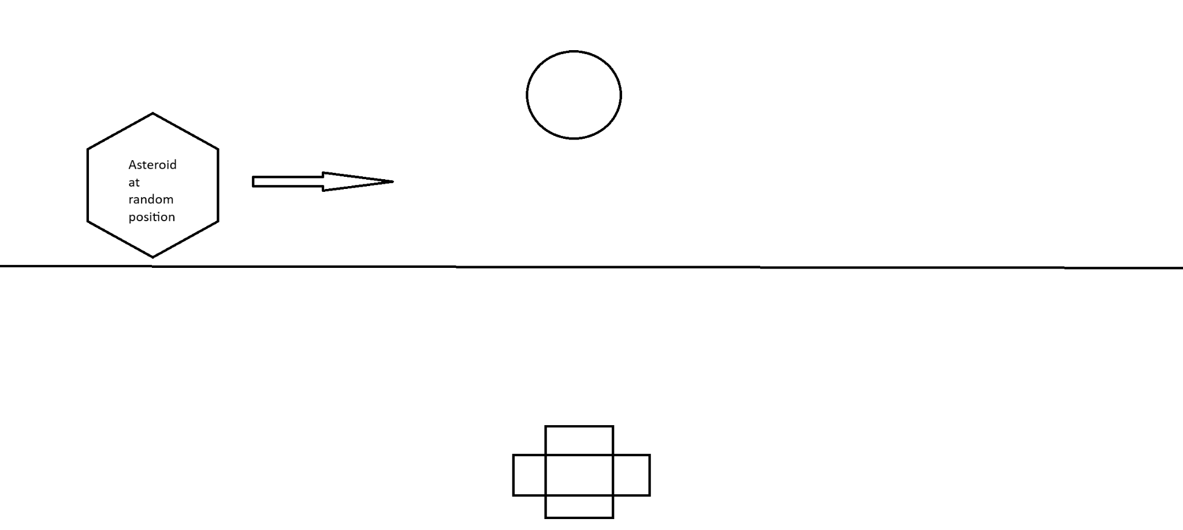

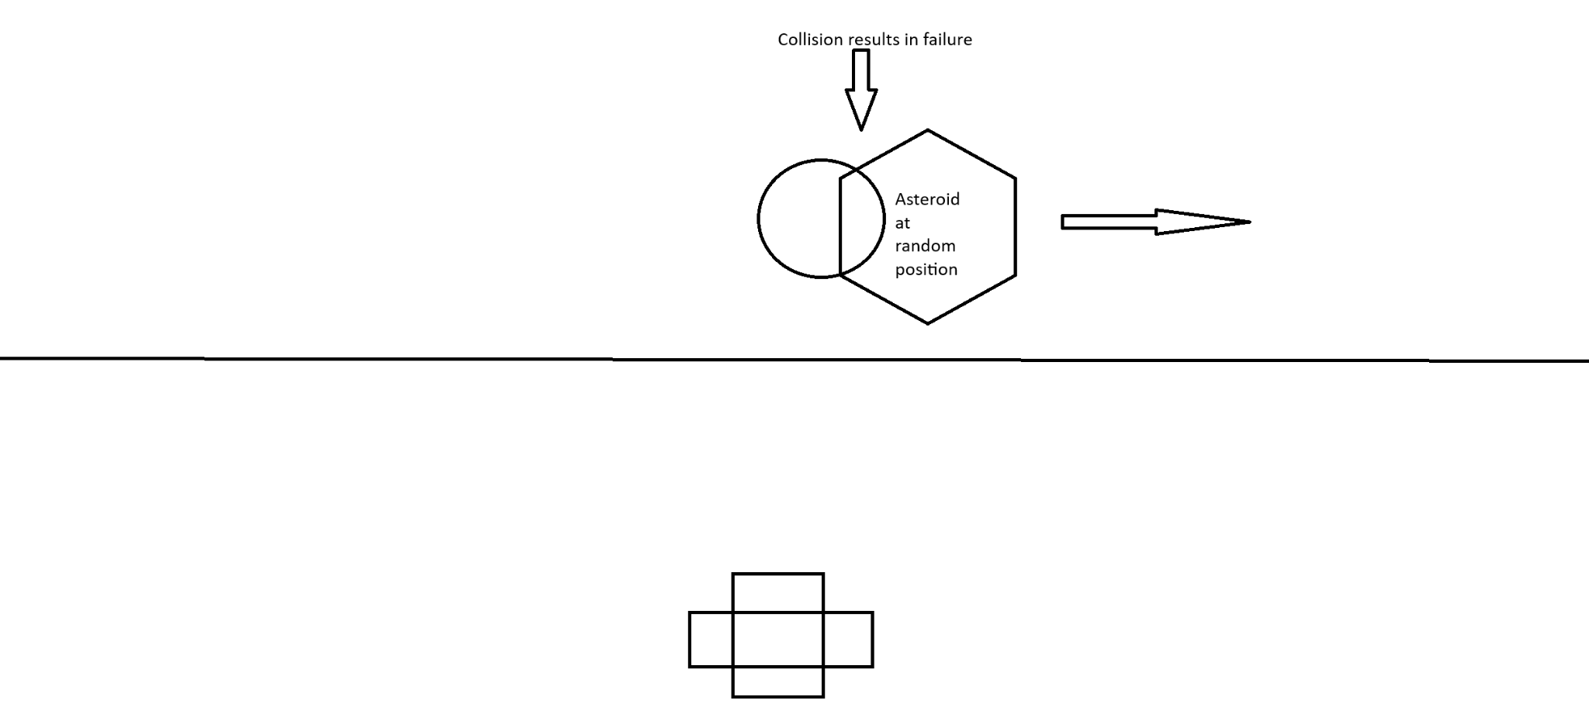

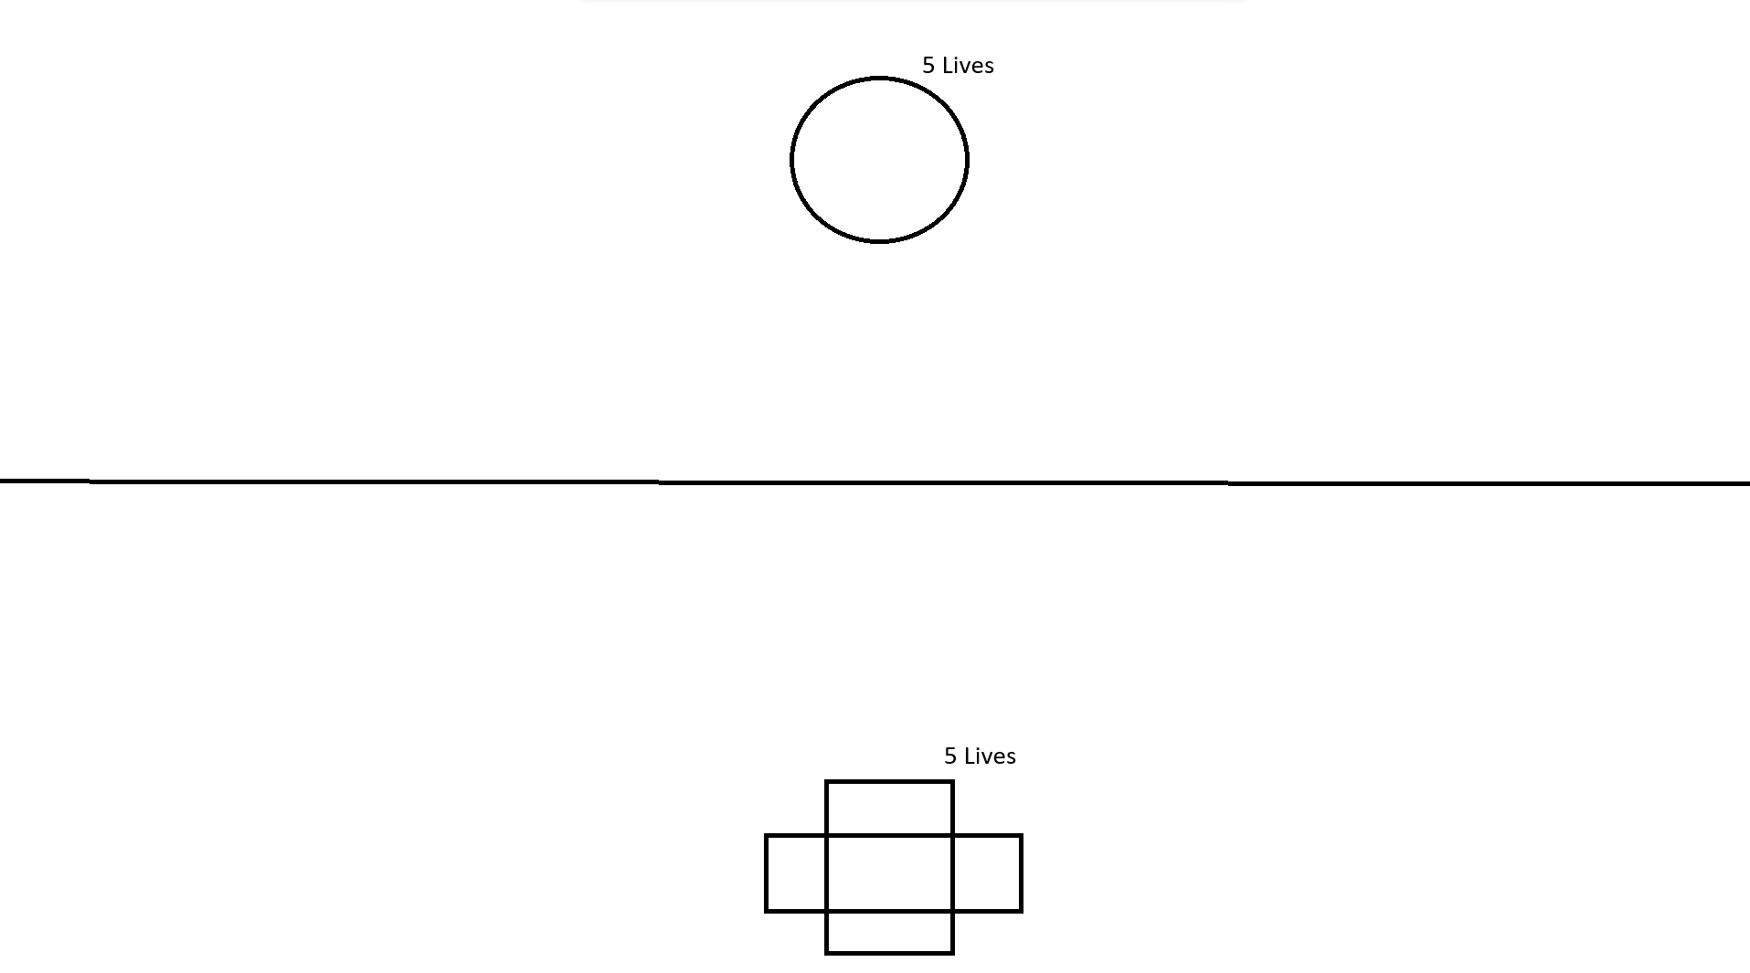

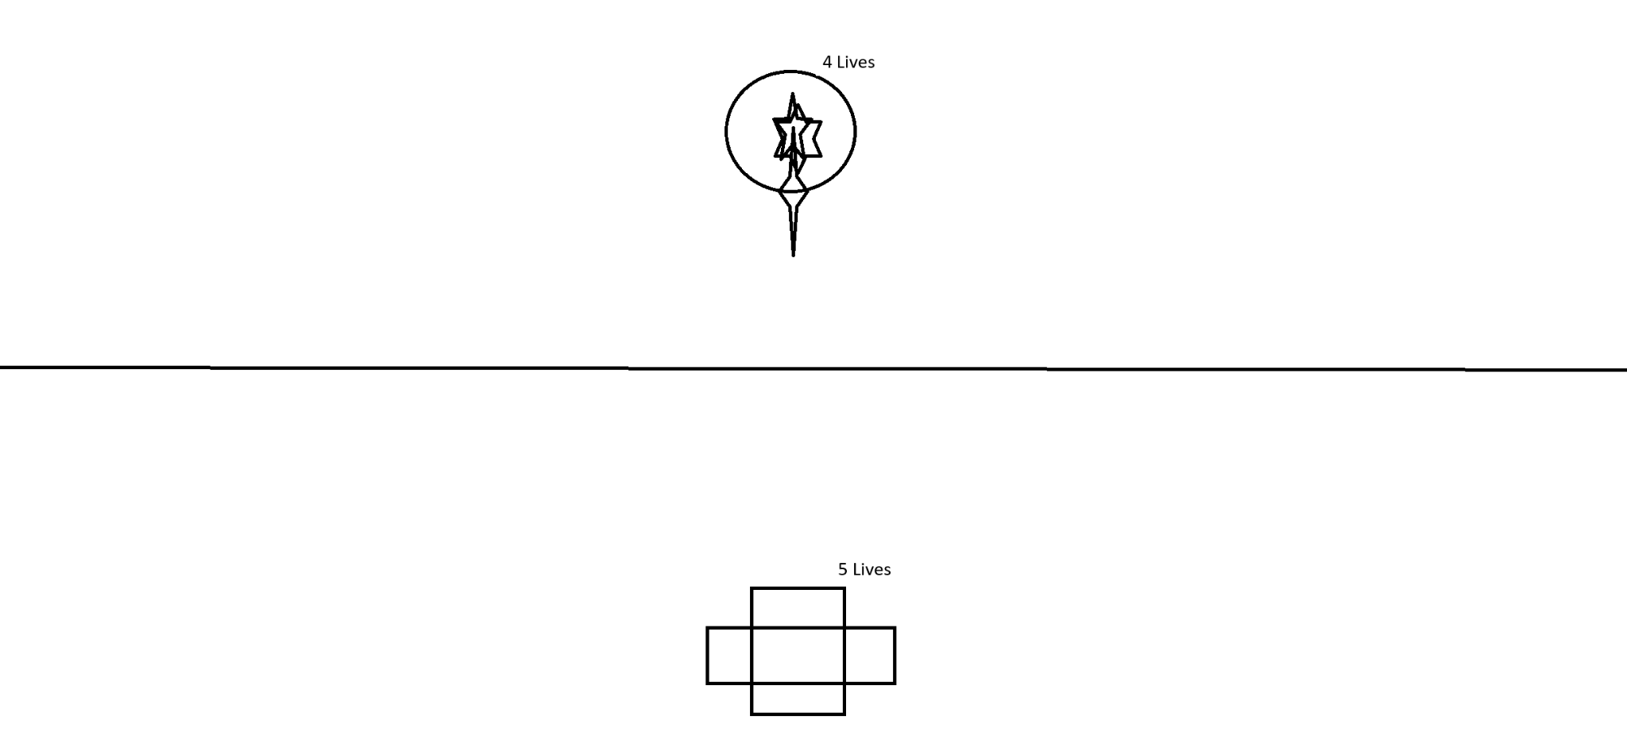

## **Graphics**

Asteroid Havoc features simple 2D graphics with colorful sprites for spaceships, asteroids, and UFOs. The background depicts a telescope image of space.

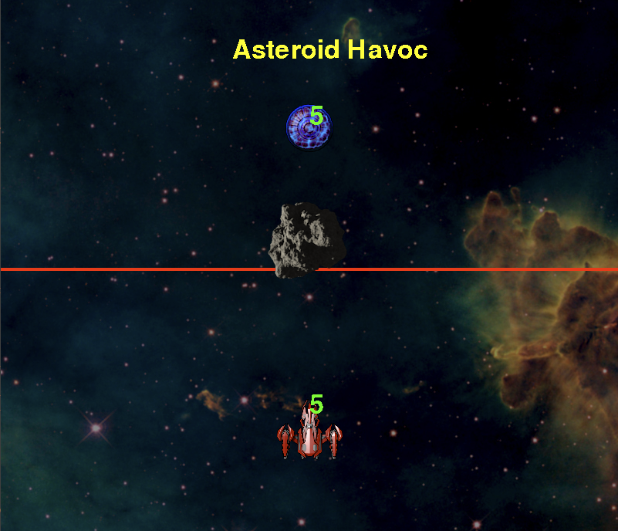

**Credit for textures:**

Background: Picture from James Webb telescope

Spaceship: <http://millionthvector.blogspot.de>, CC-BY 3.0

UFO: <http://millionthvector.blogspot.de>, CC-BY 3.0

Asteroid: [Cmdr G](https://opengameart.org/users/cmdr-g), CC-BY 3.0

Lasers: Rectangle png I made

Powerup Star: [ecovah](https://opengameart.org/users/ecovah), CC-BY 4.0

**Credit for sounds:**

Powerup Sound: [jalastram](https://opengameart.org/users/jalastram), CC-BY 3.0

Background Music: [Matthew Pablo](https://opengameart.org/users/matthew-pablo), CC-BY 3.0

Impact Sound: [Luke.RUSTLTD](https://opengameart.org/users/lukerustltd), CC0

Laser Sound: [dklon](https://opengameart.org/users/dklon), CC-BY 3.0

## **Characters and Objects with Behaviors**

### **Spaceship and UFO(Player):**

* Controls: Arrow keys for movement.
* Behavior: Navigate through the asteroid field, avoiding collisions, and shooting lasers at the enemy.

### **Asteroids:**

* Behavior: Drift through space, posing obstacles to the player's spaceship.

## **Instructions for Players**

* Use WASD to move Spaceship
* Use Space to shoot from Spaceship
* Use arrow keys to move UFO
* Use Enter to shoot from UFO
* Avoid colliding with asteroids and enemy lasers to stay alive.
* Pick up star to boost fire rate
* Hit enemy with lasers to damage them
* Grab the star for a power up

## **Scoring, Win/Lose Conditions, and Objectives**

* Scoring: Take down the enemy.
* Win Conditions: Hit the enemy 5 times.
* Lose Conditions: The game ends if a player is hit by an asteroid or is hit 5 times.